Milestone II – Multi-Agent Workflow for Purchase Comparison Assistant

1. Overview
For Milestone II, I implemented a multi-agent workflow for my AI system, the Purchase Comparison Assistant. The goal of this system is to help users compare multiple products based on constraints such as budget, intended use, and priority features. Instead of using a single agent to handle the full task, the system divides the work across multiple specialized agents. This improves structure, clarity, and reliability by assigning different parts of the decision-making process to agents with distinct roles.
The workflow is implemented as a fixed pipeline in Opal. The system begins with user input, then passes the request through three agents in sequence: a Spec Analyzer Agent, a Comparison Agent, and a Value Critic Agent. The final output is a ranked product recommendation with supporting reasoning.

2. Coordination Mechanism
The coordination mechanism used in this project is a fixed pipeline (A → B → C). The user first enters product names or links along with constraints such as budget, intended use, and priority features. This information is passed to the first agent. The output of each agent becomes the input of the next agent in the workflow. The system does not use looping or autonomous branching at this stage. Instead, the workflow is intentionally structured as a simple linear pipeline so that the data flow is easy to understand, test, and evaluate.
The sequence is as follows: User Input → Spec Analyzer Agent → Comparison Agent → Value Critic Agent → Final Output.

3. Agent Roles and Input/Output Format

3.1 Spec Analyzer Agent
The first agent in the workflow is the Spec Analyzer Agent. Its role is to process the raw user input and extract the most important information about each product being compared. This includes identifying the product name, estimated price if available, key features, strengths, and weaknesses. The purpose of this agent is to convert unstructured product input into a more organized format that can be used by the next stage of the workflow.
The input to this agent includes the user’s selected products, budget, intended use, and priority features. The output is a structured summary for each product. This structured summary allows the next agent to compare products more consistently.

3.2 Comparison Agent
The second agent is the Comparison Agent. Its role is to evaluate the structured product summaries against the user’s constraints. This agent compares how well each product fits within the stated budget, how closely it matches the intended use, and how well it aligns with the user’s top priority features. The Comparison Agent then produces a preliminary ranking of the products.
The input to this agent is the structured output produced by the Spec Analyzer Agent, along with the user’s original constraints. The output is a ranked comparison showing the order of the products and short reasoning for each ranking.

3.3 Value Critic Agent
The third agent is the Value Critic Agent. Its role is to review the preliminary ranking produced by the Comparison Agent and verify that the recommendation is logically consistent with the user’s priorities. This agent checks whether the highest-ranked product actually fits the user’s needs, whether important tradeoffs have been overlooked, and whether the reasoning is clear. If necessary, the agent adjusts the ranking or improves the explanation.
The input to this agent is the ranked comparison generated by the Comparison Agent. The output is the final recommendation shown to the user, including the best product, pros and cons, tradeoffs, and a concise justification.

4. Communication Between Agents
The agents communicate sequentially through the Opal workflow. The user input fields are connected directly to the Spec Analyzer Agent. The Spec Analyzer Agent sends its structured product summaries to the Comparison Agent. The Comparison Agent sends its ranked results to the Value Critic Agent. Finally, the Value Critic Agent sends the validated recommendation to the Output node.
This design supports clear communication between agents because each agent receives only the information relevant to its role. The structured data passed between stages also reduces ambiguity and makes the workflow easier to explain and debug.

5. Tools, APIs, and Dataflow
The system currently uses Opal as the workflow platform for implementing the multi-agent pipeline. The user-facing front end was designed separately in Figma Make, while Opal is used to orchestrate the backend logic of the multi-agent system. At this stage, the system primarily uses user-provided product names or links as the main data source. Future development may include web retrieval tools or external APIs to improve product specification and pricing accuracy.
The dataflow begins with raw user input, which is transformed into structured product summaries, then into a ranked comparison, and finally into a validated recommendation. This staged transformation reflects the responsibilities of each agent and supports explainable decision-making.

6. Failure Handling and Low-Quality Output
The workflow includes simple strategies for handling incomplete information and low-quality outputs. If the Spec Analyzer Agent cannot determine all details about a product, it is expected to preserve the available information rather than invent missing values. If the Comparison Agent cannot strongly distinguish between products, it still produces the best possible ranking using the available data. The Value Critic Agent acts as a verification layer by checking for weak reasoning, missing tradeoffs, or rankings that do not align with the user’s priorities.
If the overall input is incomplete, such as missing budget or intended use, the system may produce a weaker recommendation. However, the critic stage helps reduce this problem by identifying gaps and improving the final explanation. This makes the workflow more reliable than a single-agent approach.

7. Conclusion
The multi-agent workflow improves the Purchase Comparison Assistant by dividing the problem into specialized stages. The Spec Analyzer Agent organizes product information, the Comparison Agent evaluates products against constraints, and the Value Critic Agent verifies and strengthens the final recommendation. The fixed pipeline implemented in Opal provides a clear coordination mechanism and satisfies the requirement for a multi-agent workflow with distinct agent roles, defined communication, and failure handling.
Figma Link:
https://www.figma.com/make/Ba5EjkOCBDyWF0U69Dt4Yn/Purchase-Comparison-Assistant?t=65yxKLvCQZOBwKPK-1
Opal Link :
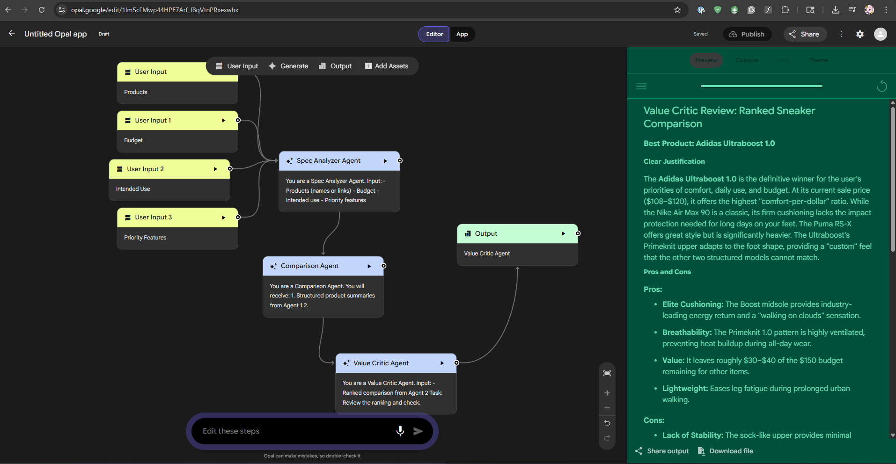
https://opal.google/app/1U2jJjWtjHG27rbKEM9zSi2YJ4-hgDYTc

